LED Display Panel Setup

This is a document outlying everything needed to setup the LED Display panel.

# Burning the .img file onto the SD Card.

The first thing you will need to do is burn the .img file onto a SD card. This will be the operating system that will run the whole program. The operating system is based off the [Raspbian Lite Stretch](https://www.raspberrypi.org/downloads/raspbian/). To do this you will need an SD card of at least 8 GB of memory. Any less is not recommended.

1. Insert your SD card onto the computer.
2. Download the program [Win32DiskImager](https://sourceforge.net/projects/win32diskimager/) if not already installed. This will burn the image file onto your SD card. Open up Win32DiskImager. In the Image File section put

D:/LED Display ImagesSD/Model 3 A+/LED_display_RPi_3A+

1. **WARNING:** Make sure you select the right Drive that corresponds to your SD card. If you select the wrong one it will overwrite anything you have in there. Also note that anything inside your SD card will be lost so do not forget to save any useful data.

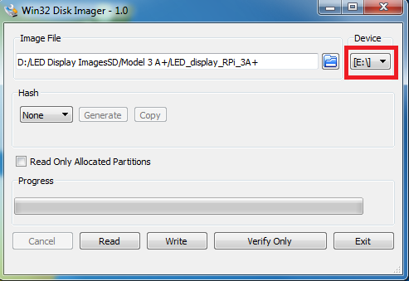

1. Press the “Write” button and wait for the process to finish.
2. Once done you will have the OS needed to run the LED display panel.

# Changes made to the Raspberry Pi to make the program work.

Unfortunately the Raspberry Pi needed some modifications in order to make the LED program work. Below are the following changes:

## DetermineIsRaspberryPi2

Head to the directory “/lib/gpio.cc” and find ‘static bool DetermineIsRaspberryPi2(){…}’ and directly beneath it write ‘return true’. This will determine that the Raspberry Pi being used is of an older model:

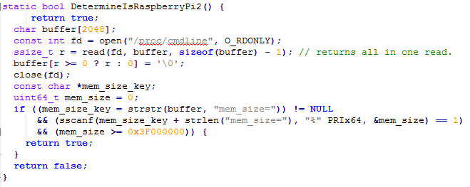

## Realtime Scheduling

The KIB display program will not work unless realtime scheduling is enabled. To do this, follow the instructions on this page: <http://jackaudio.org/faq/linux_rt_config.html>

## Raspberry Pi UARTs

We need to dedicate the serial port “dev/ttyAMA0” to the KIB display program to work. Head to /boot/config.txt and add at the bottom of the text file:

dtoverlay=pi3-disable-bt

For further reading: <https://www.raspberrypi.org/documentation/configuration/uart.md>

## Isolate CPUS 3

We need to dedicate a cpus to just running the program. Edit the /boot/cmdline.txt and after “rootwait” add :

isolcpus=3

## Starting the KIB program on startup.

Edit the /etc/rc.local file and at the bottom of the page add:  
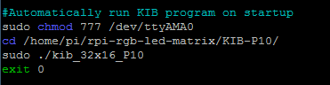

When the Raspberry Pi starts up the KIB display program will automatically start.

## Disabling Sound Module

Switch off on-board sound by writing:

dtparam=audio=off

in /boot/config.txt.